- 1Initial SDK and Board
  - sdvr_sdk_init() :
Initial driver and resource. This function should be called only once
per session.
  - sdvr_get_board_count() :
Get the installed board count in this PC.
sdvr_set_av_frame_callback() :
Register callback routine for available video frames.
sdvr_set_video_alarm_callback() :
Register callback routine for video analytic alarm.
sdvr_set_sensor_callback() :
Register callback routine for physical trigger input.
sdvr_set_signals_callback() :
Register callback routine for signal triggers.
  - Click “InitDvrBoard” → “Init All DvrBoard” :
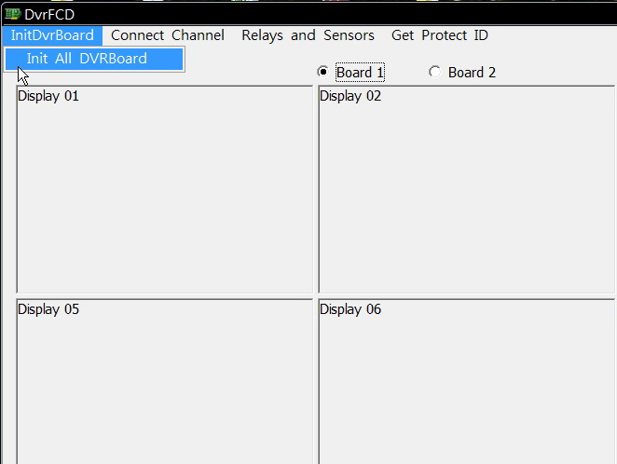
  - Select “*.rom” firmware file to upgrade for every cards.
sdvr_upgrade_firmware() :
Upgrade board firmware.
  - Get board’s config and status.
sdvr_get_board_attributes() :
Get board’s supported video standards.
sdvr_get_sdk_params() :
Get SDK resource allocation parameters.
sdvr_get_pci_attrib() :
Get board’s PCIe attributes.
sdvr_get_board_config() :
Get installed board’s current configuration.
  - Setup parameters to board for every cards.
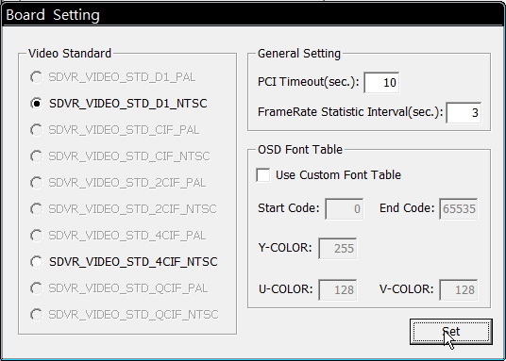
In “video Standard” block, the un-supported video standards of this board
can not be selected.
Click “Use Custom Font Table” to load a “*.bdf” font file to support unicode multi-language like Chinese and set the OSD color, if not specify any one, the system will use a default font table setting.
sdvr_set_sdk_params() :
Set SDK resource allocation parameters.
sdvr_board_connect() :
Connect SDK to board and set attributes.
sdvr_set_date_time() :
Set date and time on board’s real-time clock.
sdvr_get_firmware_version_ex() :
Get board firmware revision number.
sdvr_set_watchdog_state() :
Set or reset board’s watchdog timer.
sdvr_osd_set_font_table() :
Specify a different OSD font table.
sdvr_osd_use_font_table() :
Select a different font for OSD text.
  - Get board protect ID. (Notice: call this function after connect board OK.)
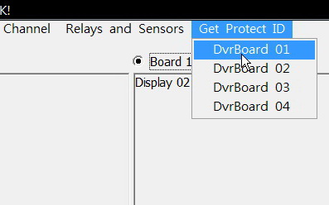
sdvr_get_protect_id() :
Get board protect ID as hexadecimal number and also shows some firmware information by call sdvr_get_firmware_version_ex().
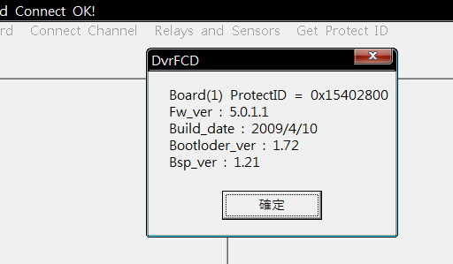
- Connect Channel to Preview
  - Click “Connect Channel” to select channel.
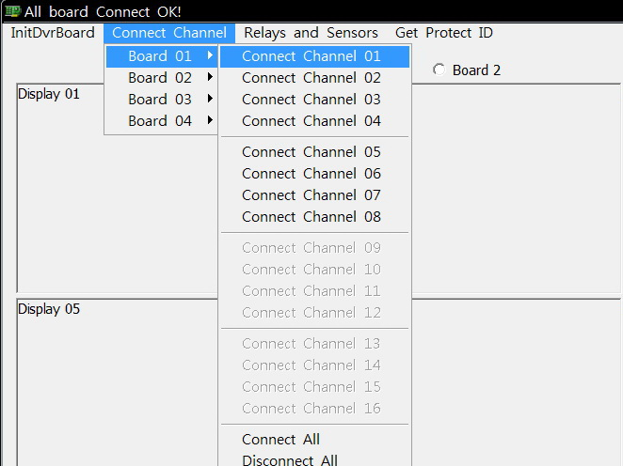
A popup dialog will show all parameters of channel setting.
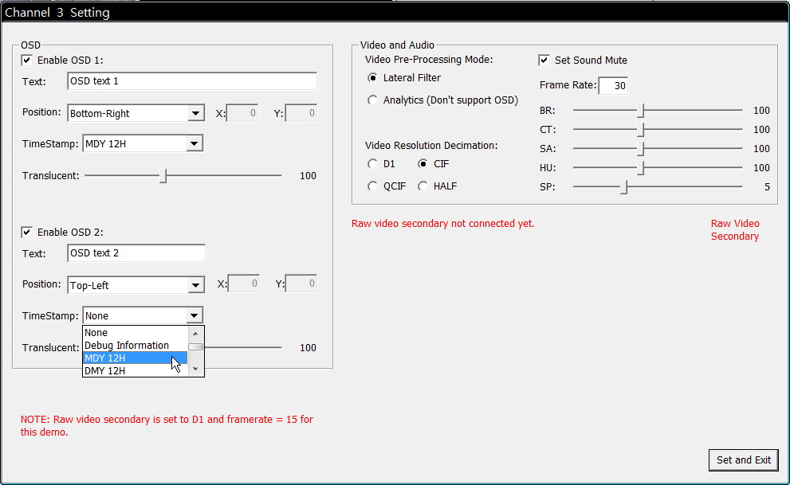
sdvr_create_chan() :
Create an encoding or decoding channel.
sdvr_stream_raw_video() :
Enable or disable streaming raw video from board to host.
sdvr_stream_raw_audio() :
Enable or disable streaming raw audio from board to host.
sdvr_osd_text_config_ex() :
Set multiple Unicode OSD texts of up to 100-characters each.
sdvr_osd_text_show() :
Show or hide OSD text.
sdvr_get_video_in_params() :
Get channel image hue, saturation, brightness, contrast, sharpness
value (call this after create channel).
sdvr_set_video_in_params() :
Set channel image hue, saturation, brightness, contrast, sharpness
value (call this after create channel).
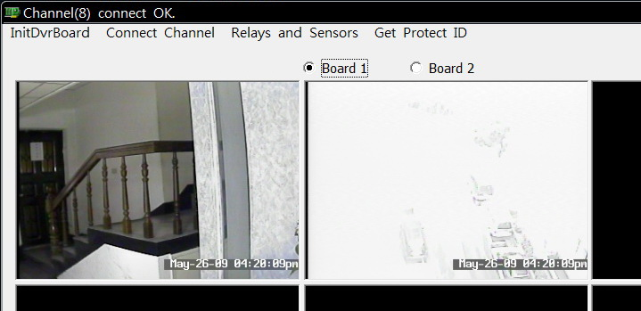Click radio button “Board 1” ~ “Board 4” to switch the preview board channel.
sdvr_stream_raw_video_secondary() :
Enable or disable secondary streaming raw video from board to host.
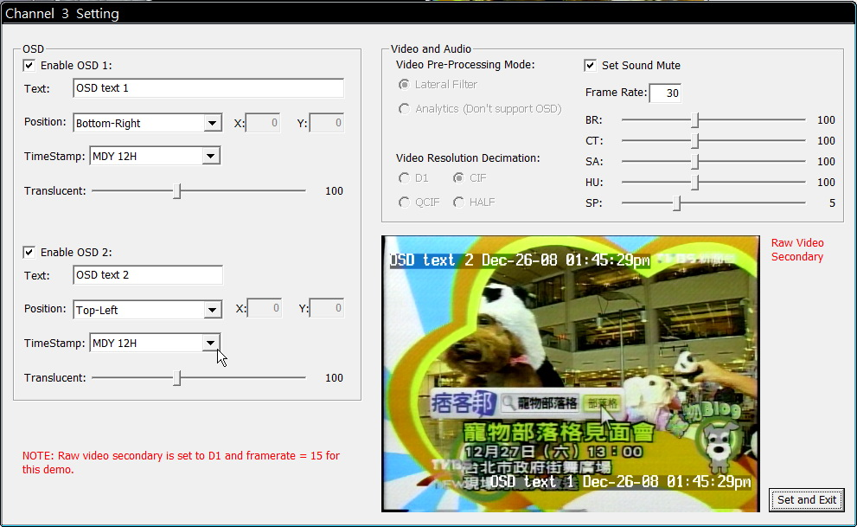

- Modify Channel Setting
- Right click on a connected display area.
Notice: The “Raw video secondary“ API will be supported in next version, now the video is show as primary video stream.
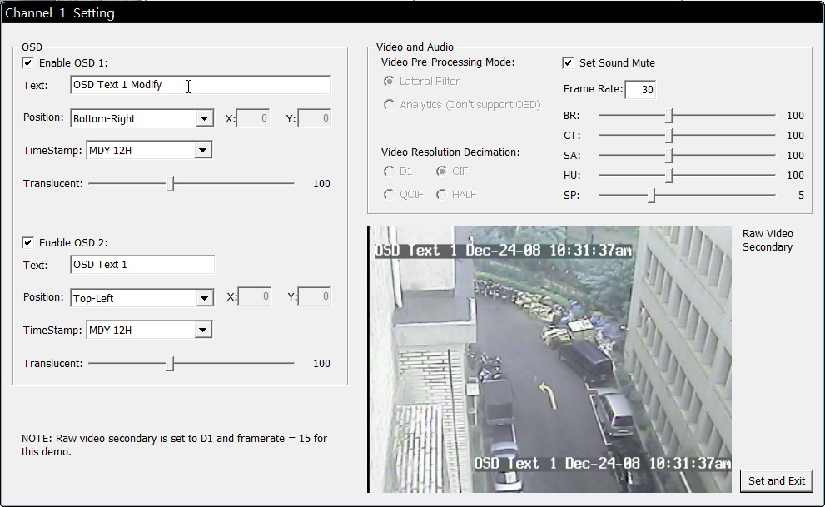
The popup dialog will show you the Items that can be modified (not grayed items).
- Motion Detect Setting
Double click on a connected display area.
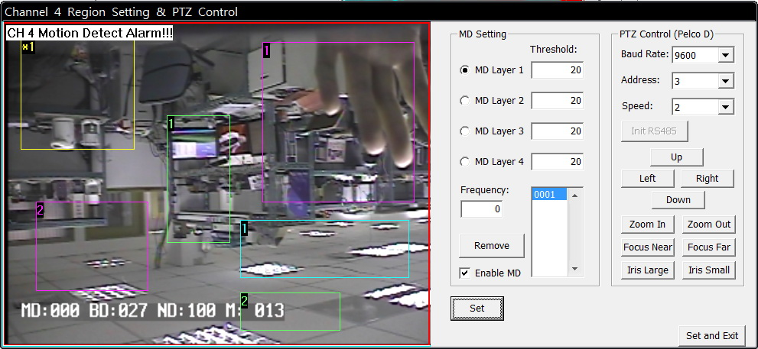
In this popup dialog, the default status is in add region mode, drag and drop to add one region and click “Add” to drag and drop the second, etc.
Select radio button and click “Remove” to remove region.
Input “Threshold” and click “Set” for preview effect or “Set and Exit” to exit.
sdvr_set_regions_map () :
Set regions for motion and blind detection, and privacy regions.
sdvr_enable_motion_detection_ex () :
Enable motion, blind, and night detection.
- Relays and Sensors
- Click “Relays and Sensors” → “Board 01”
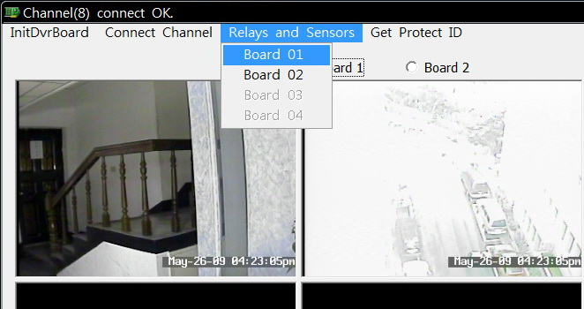
A popup dialog will show.
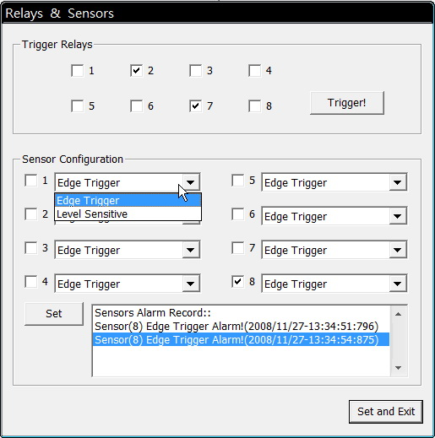
In “Trigger Relays” group, check the relay number and click the “Trigger” button, will trigger the IO out device.
In “Sensor Configuration” group, check the sensor number, set the trigger mode and click the “Set” button to apply setting for callback, then, when sensor trigger it, the list will show alarm mode and time.
sdvr_trigger_relay() :
Trigger an output relay.
sdvr_config_sensors() :
Define sensor criteria and initial state.
- PTZ Control
- Double click on a connected display area.
In this popup dialog, if not initial RS485 yet after connected board, click ”Init RS485” button first.
sdvr_init_uart() :
Initialize UART for RS232 - RS485 interface.
sdvr_write_uart() :
Write one character to the UART.
- Disconnect Channel ,Close Board and Close SDK
- Disconnect channel. Click the connect channel menu channel number again to uncheck it.
sdvr_stream_raw_video() :
Enable or disable streaming raw video from board to host.
sdvr_stream_raw_audio() :
Enable or disable streaming raw audio from board to host.
sdvr_destroy_chan() :
Destroy encoding or decoding channel; recover sources.
- Close board. Click the “InitDvrBoard 01” menu to uncheck it.
sdvr_board_disconnect() :
Disconnect from board.
- Close SDK.
sdvr_sdk_close() :
Close SDK. Must call this function before call sdvr_sdk_init() again.

